**Maglev Robot/Drone Research**  
**Dionne Wijayawickrama**

**Idea #1: Magnetic Levitation Hovercraft Video**

<https://youtu.be/9Q5_BVliFfE>

[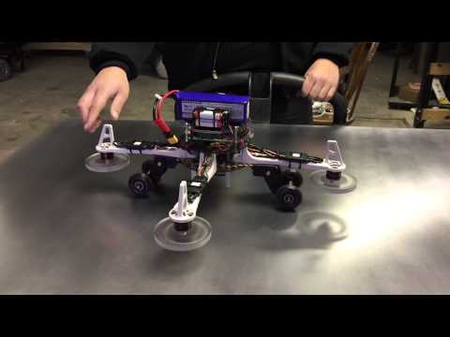](https://youtu.be/9Q5_BVliFfE)

Fanucmanl 
2 years ago 
This is just a DJI Flamewheel 450 drone upside down. I use 5/8" x 1/4" N52 class neodymium magnets 
from K&J Magnetics DA4-N52 $3.22 each. It takes 8 magnets per wheel. Each faces in the opposite 
direction. First one North, next one South, then North, then South. All eight are in opposite direction. You 
can use any drone motor and ESC that will spin the wheel. I used DJI 30A ESC's and 2212 920KV CW 
Brushless Motors. I upgraded them to the DJI E800 motors and ESC's. All you need is a servo tester to 
generate the RC PWM 1.0 to 2.0ms signal for the ESC. (DO NOT POWER THE ESC FROM THE SERVO 
TESTER!) The ESC generates its own voltage as a BEC battery elimination circuit sometimes. Just send 
the ground and the PWM signal from the servo tester to drive the ESC. I may be able to send you a wheel 
or more. Message me your email and I will tell you what I have available. 

This is a four engine magnetic hovercraft that I designed. I use common quad copter ESC's and outrunner motors to spin four poly carbonate wheels with embedded neodymium magnets at a high rate of speed This action induces Eddy Currents in the aluminum plate below that generates enough lift for the entire vehicle to ride upon. This video relates to my earlier posted video where I proved out this Mag-Lev process on a small copper plate. See Video Below.

|  |  |
| --- | --- |
| 0:02 | 0:30 |
| 0:42 | 1:09 |

|  |  |
| --- | --- |
| Does the source use the same magnets we have | The source does use N52 magnets, however they use 5/8” x1/4” disks instead of the cubes we have. This should be matter because we have square N52 magnets with similar times. |
| Does the source use the same motors we have (2216 or 2212)? If not, how do the motors compare? | It does use 2212 outrunner motors at 920KV motors. We also have 2212 motors and we have the bigger but faster 2216 Motors. So if we need more speed, we can use the 2216 motors. However they later switch to DJI E800 motors. |
| Does the source make a Halbach array? | No the creator doesn’t use the a Halbach array for their design. He mentions that the magnets are just aligned in opposite directions, North, South, North....  If we need a stronger magnetic field in our design we can use the Halbach array which can increase the strength more compared to the alternating poles in this design. |
| Does the source demonstrate their design working? Do they use copper or aluminum? How thick? | They source demonstrates it working effectively and being able to move around during levitation as well. The material used for the plate is aluminum like our design but the thickness is not specified. Based on speculation, it could be an inch or two in thickness. |
| Does the source explain how they've built their rotor?  -give advice  -specifications like thickness/size | * They mentioned building the rotor out of poly carbonate. We use PLA in our 3d printers. However, in this situation, the filament material isn’t too significant as a factor. If the design is strong and secure, it will work * Also the Neodymium magnets are embedded to the rotors. We don’t need to glue or embed since we can use a lid and have smaller hole at bottom to make sure they stay in place. * The use a DJI 30A ESC controller to control the motors. We have our own remote control to control the motor. * The also use DJI Flamewheel 450 drone body upside down. We can use a similar design or get one online as we progress into building the full drone. * They mention using servos for the wheel design to lower it down. This isn’t necessary since we can use a platform to keep it above the ground. We don’t need to that extra length with the given time. |
| Will the design be printable in a 4-6 hour window (size/complexity)? | Although the design can be made within the time frame, we do not have the material needed to make the specific disk. Also the whole wheel design is not necessary for this project. However it is possible to design similar rotor but with square holes instead of circular |

**Idea #2: Magnetic Levitation Rotor**

[**https://medium.com/@panothai.pornprinya/magnetic-levitation-30d527a6733f**](https://medium.com/@panothai.pornprinya/magnetic-levitation-30d527a6733f)

[**https://youtu.be/IsLgv-scuNA**](https://youtu.be/IsLgv-scuNA)

[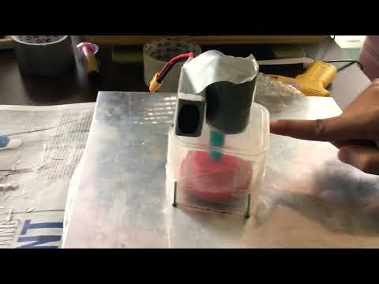](https://youtu.be/IsLgv-scuNA)

|  |  |
| --- | --- |
|  |  |
|  |  |

|  |  |
| --- | --- |
| Does the source use the same magnets we have | The source uses N42 neodymium magnets which is a lower grade compared to our N52 neodymium magnets. This means that the magnets used in this source have a weaker magnetic field. This means our design can have a stronger field making it easier to levitate and they are roughly the same density as well. |
| Does the source use the same motors we have (2216 or 2212)? If not, how do the motors compare? | The source uses 2212 motors which we do have. We can also use the 2216 motors which are slightly bigger but more powerful. It can spin faster and hopefully be able to levitate easier despite being slightly bigger.  However, later on they switch to a lower speed and higher torque DC motor. It spins 10 times slower than the brushless motor. The reason for this is because using the higher speed motor caused too much vibration. This vibration caused a magnet to come out of the disc. Afterwards, the disc lost stability and shattered. Ultimately, the motor's high speed could not be supported by the disc's structure due to vibration.  This problem can avoided in our design by attaching a lid to make sure the magnets stay in the disc. In the source, the disc broke when it lost stability as one of the magnets came out, disrupting the balance in the disc. Furthermore, building a thicker disc would be beneficial as well for more stability. However it must not be overdone as it can not levitate well if it’s too heavy. |
| Does the source make a Halbach array? | Yes this source does use the Halbach array. This means it that one side is stronger than the other. It also means it should be stronger than if the magnets were aligned the same way. |
| Does the source demonstrate their design working? Do they use copper or aluminum? How thick? | Yes the source show it levitating and being able to move in the video linked above.  At first, the creator uses a thin copper sheet. They mentioned it didn’t have any significant effect. After folding it, there was some improvement. Since thickness is a of the plate is a significant factor for levitation, they switched to a 5mm aluminum plate. |
| Does the source explain how they've built their rotor?  -give advice  -specifications like thickness/size | * They use a 5 mm aluminum plate * Rotor dimentions are 7cm diameter, 2cm thick and 30g weight * They use a 12 magnet N42 Neodymium Halbach Array * For controlling the motor they used a micro controller instead of a remote control to control the speed of the motor * The code is basically just starting the motor and letting it spin for 20 seconds before making it stop. However we can still use a remote control for our design as they both achieve the same result essentially. A micro controller is just automated while a remote control is manual * They but the rotor in a plastic box for safety and make the disc is 1-2mm above the ground and not touching the plate. We can do this with our testing arm platform and putting a plastic box on top of it for safety. |
| Will the design be printable in a 4-6 hour window (size/complexity)? | Yes the disc/rotor design is able to printed in 4-6 hours. It is not a big nor complicated design |
| What strengths/weaknesses does the design provide for our goal(s)? | It uses the Halbach Array meaning one side is stronger than the other. It would be stronger than having the magnets all facing the same side.  Since the box protecting it is attached to the rotor, it provides a lot of unnecessary additional weight. We can avoid this as in our design, the box for safety is not attached to the rotor. |

**Other Research**

**Magnet Value**

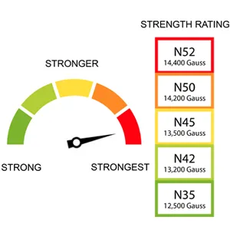

**As we can see, N52 is the strongest strength of magnets on this scale**  
**kVvs KV for the motors**

**Kv is kilovolts**

**Kv is the constant velocity of the the motor.**